Lab 1 - CS2506 – Alexander Stradnic – 119377263

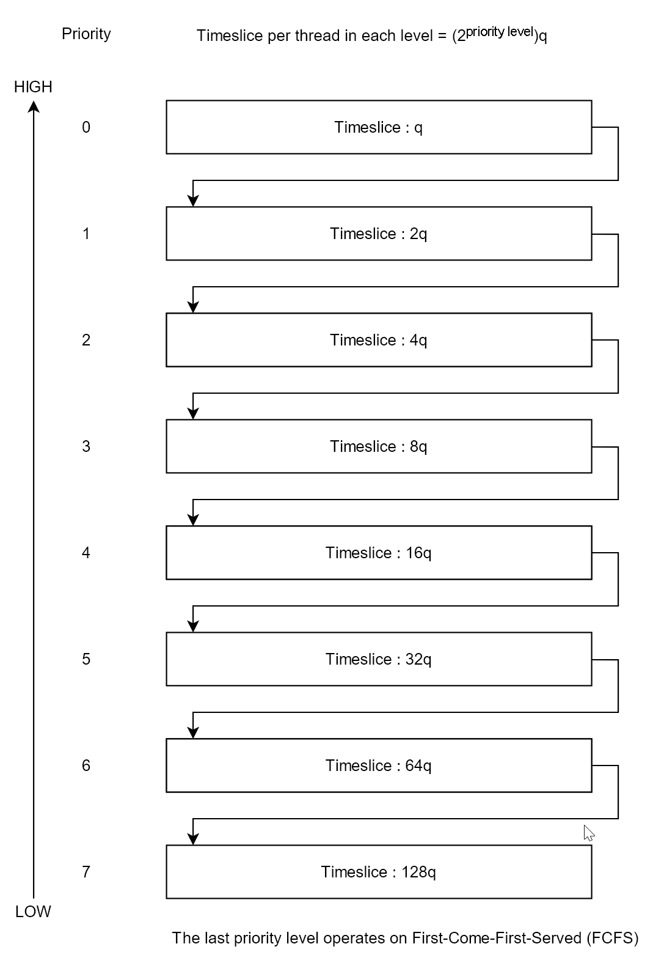

**Task 1**

If q = 1 for 1GHz, then q = 1.25 when the frequency is reduced to 800MHz.

When there are no user processes left to execute the system runs the Idle Process which is always the lowest priority process.

**Task 2**

while system.running:

|

while queues is empty and blocked_queue is empty:

execute(idle_process, idle_process.time_slice) *// if the queues are empty, run the idle process. it has the lowest priority of any process*

for queue in queues:

for process in queue:

if process.state == blocked:

move(process, queues[process.priority-1]) *// if the process is blocked, move it up a level*

else if process.state == ready:

execute(process, queue.time_slice) *// execute the process for (2process.priority)q*

if process.state == ready:

move(process, queues[process.priority+1]) *// if the process is still not finished after being executed for the duration of its time slice, move the process down one level*

for process in blocked_queue:  
 if not process.blocked:

move(process, queues[process.priority-1])

function execute(process, time_slice):

while time_slice > 0:

exec(process)